MACH4METAL

metalworking machinery
Transito 21,
6909 DA BABBERICH, Netherlands
Tel. + 31 (0)316 – 247123
Fax. + 31 (0)316 - 247956

Bank No : 66.52.13.883
IBAN : NL33 INGB 0665 2138 83
BIC : INGBNL2A
www.mach4metal.com

POREBA TCG 160 x 10.000
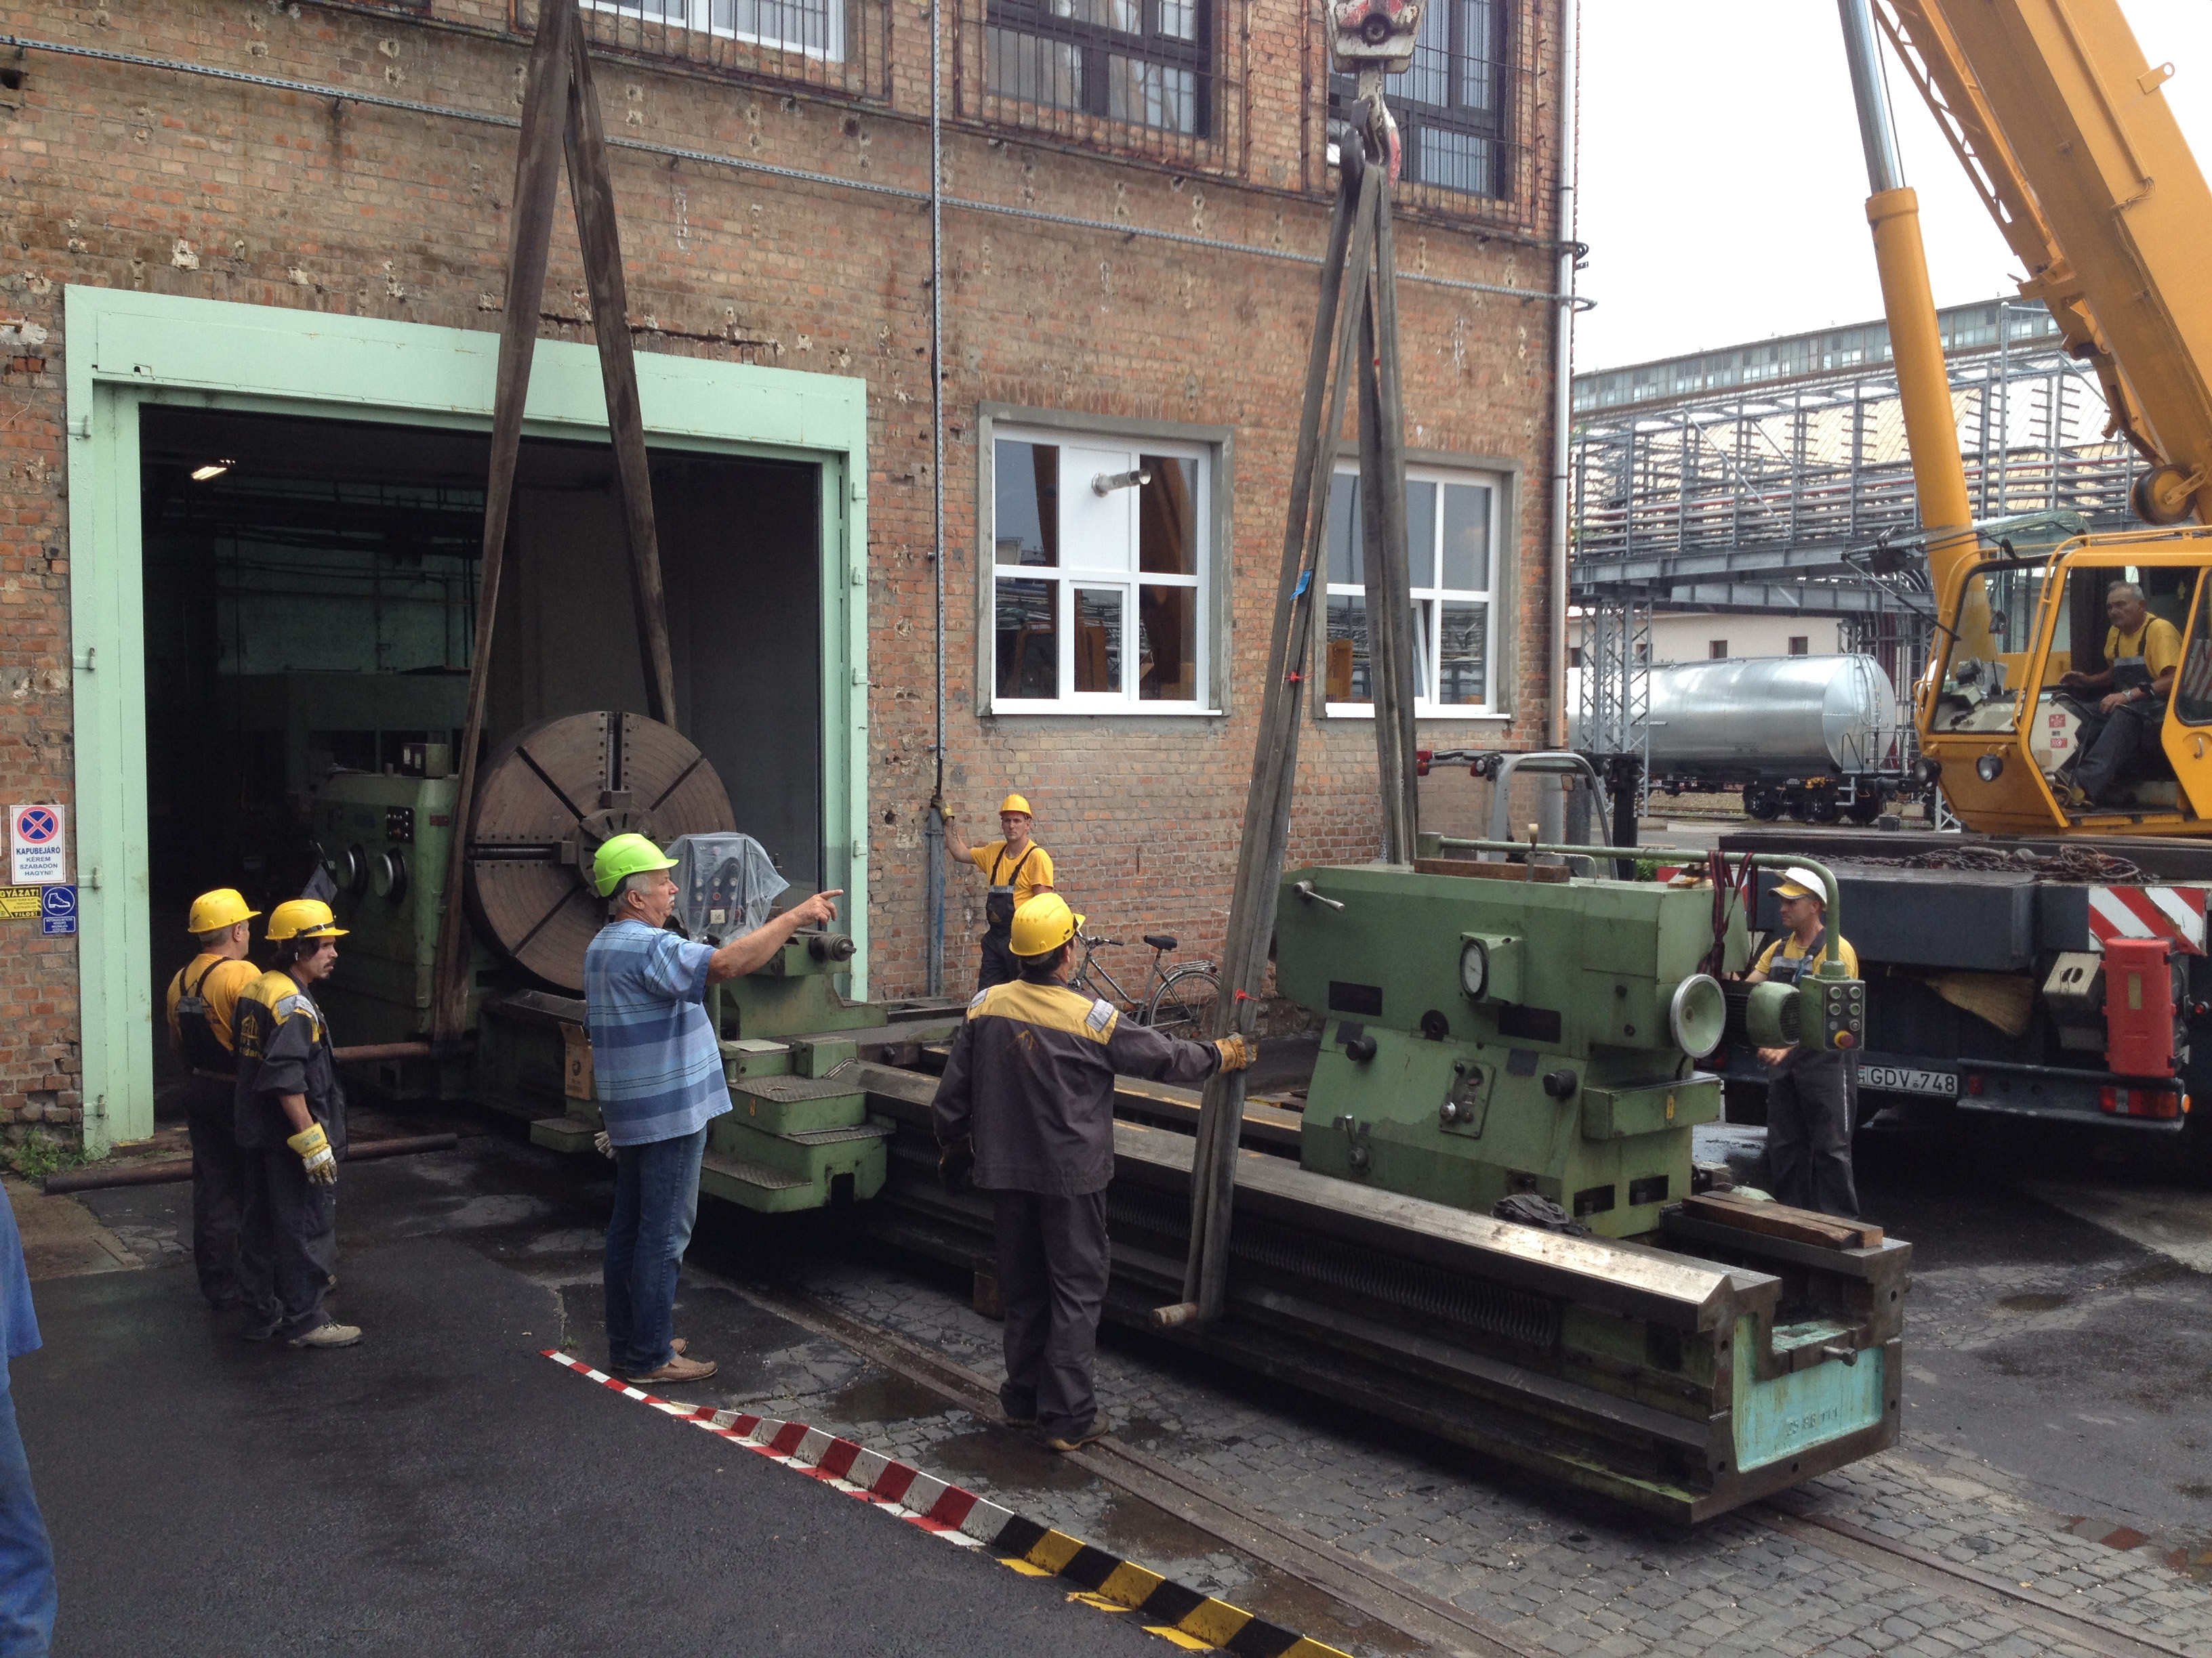
- Make : POREBA Poland
- Type : TCG 160/10M
- Age : 1173 - 251
- Serial : 1992

- Max. turning Ø over bed : 1600
- Max. turning Ø over carriage : 1300

- Centre height : 800
- Centre distance : 10.000
- Work load between centre : 40.000
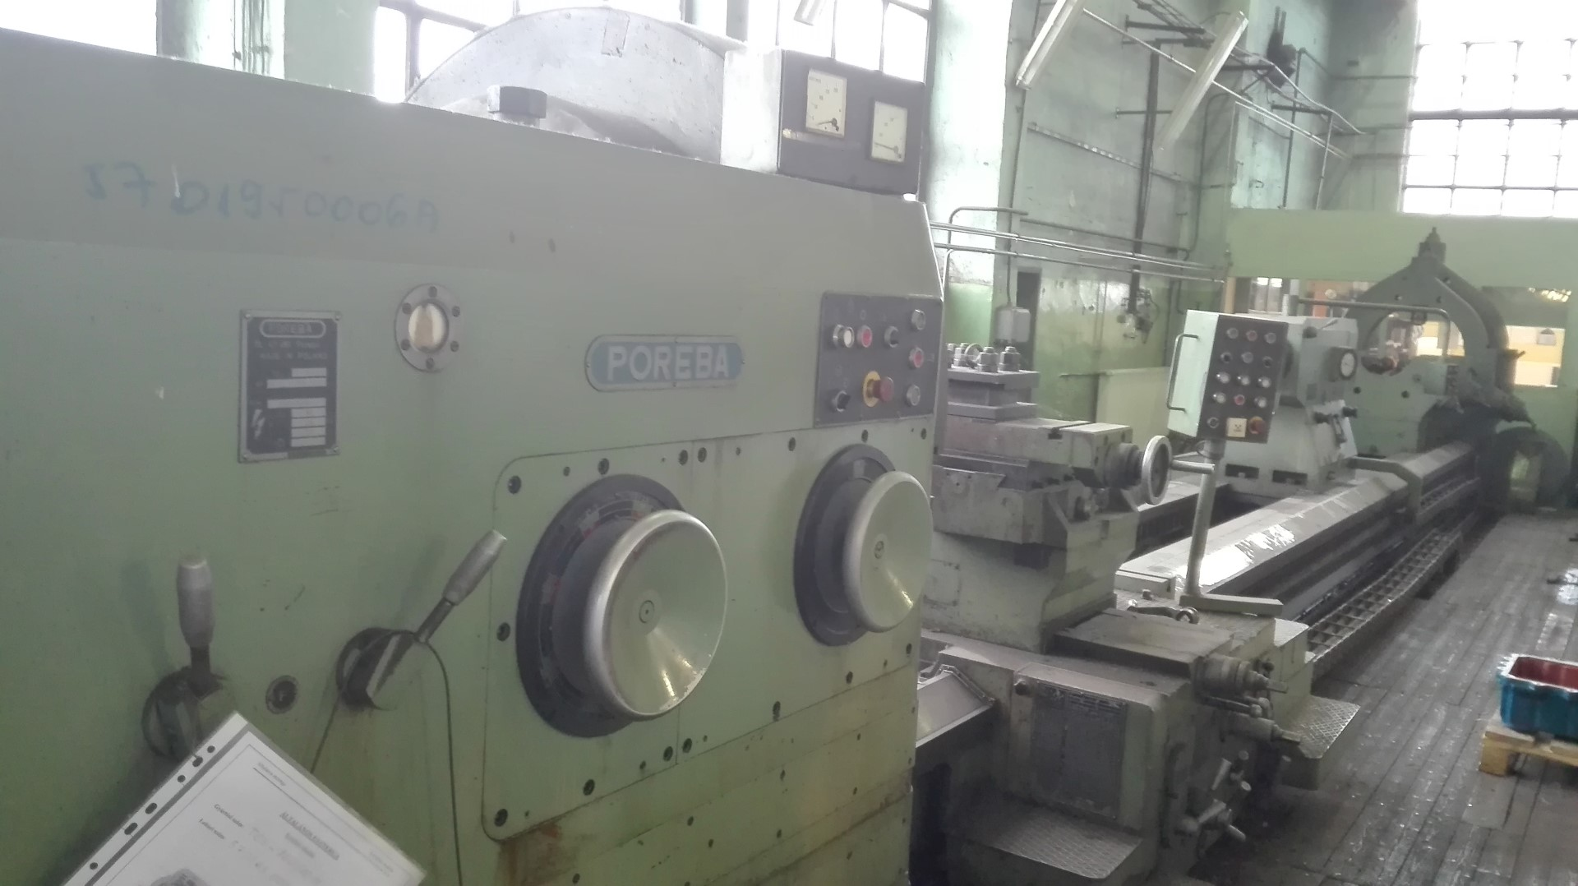
- Turning speeds 4 steps : 200
- Spindle bore : 105
- Bed width : 1600

- 4 chuck Ø : 1600
- Clamping Ø : 1400
- Min. clamping Ø : 230

- Motorised tailstock
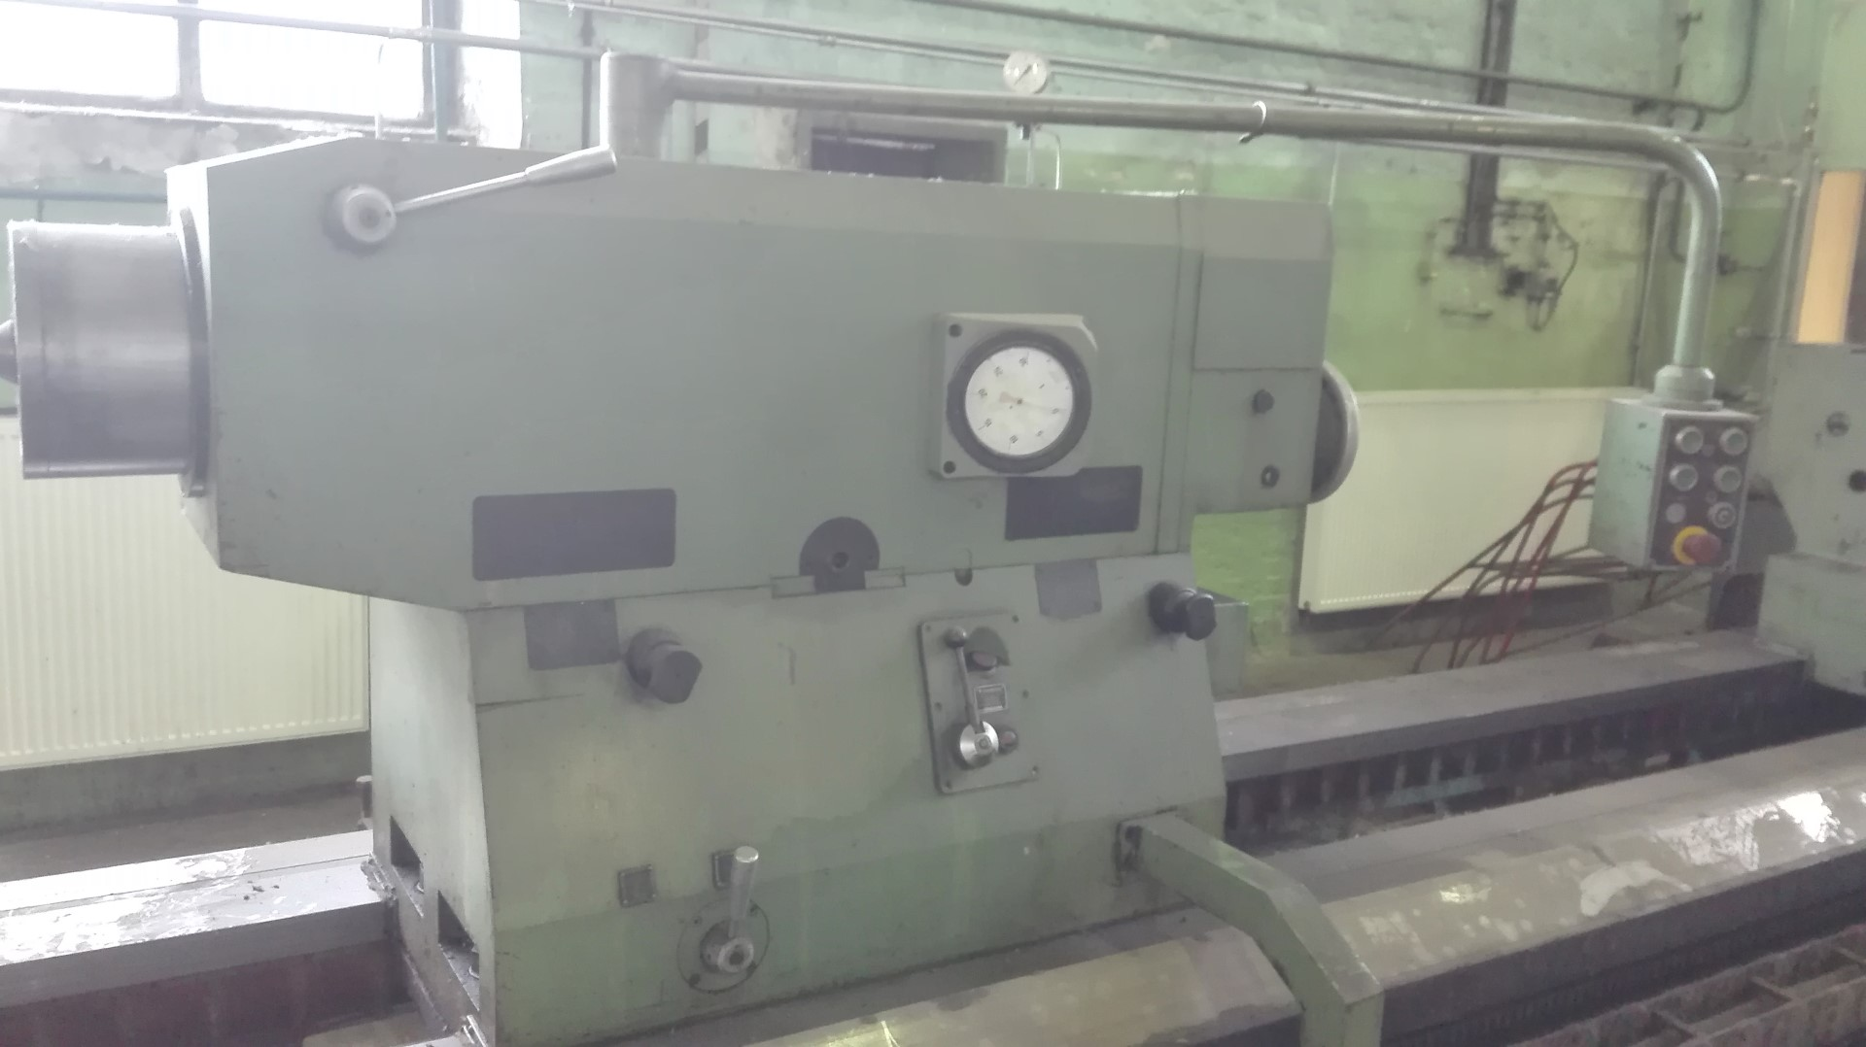
- Pinole Ø : 280
- Stroke : 300

- Dimensions
- Length : 15.360
- Width : 3.000
- Height : 2.400
- Weight : 51.700
- Power : 75 kW
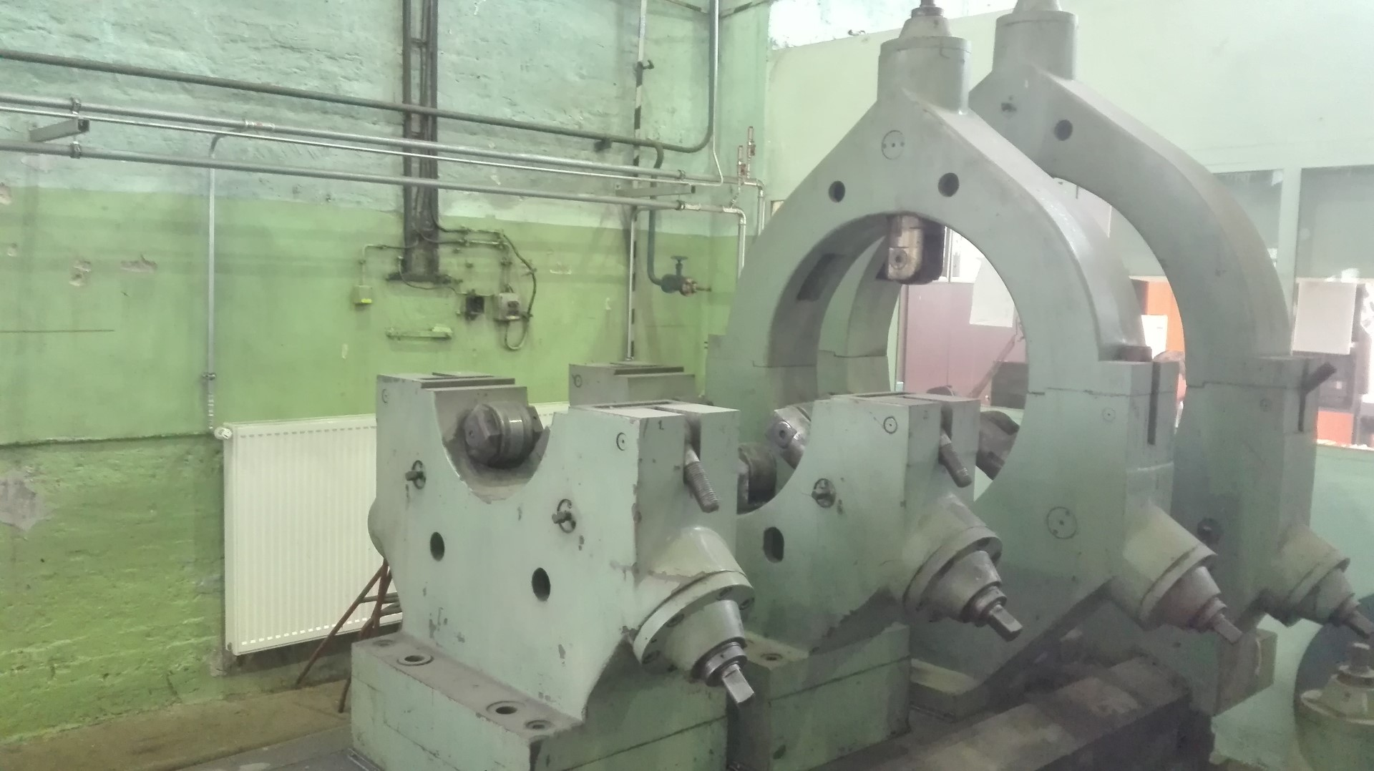

- Incl. 5 x steady rest Ø ..
- Incl. milling support
- Incl. Grinding support
- Powered quill / tailstock
- FA 20 Coolant filtration syste

Please Note: The above information has been obtained to the best of our ability and belief from, and from the manufacturers where possible. It is given in good faith, but its accuracy can not be guaranteed. Accordingly, it will not form a representation or constitute contractual terms. We advise you to check any vital details!

